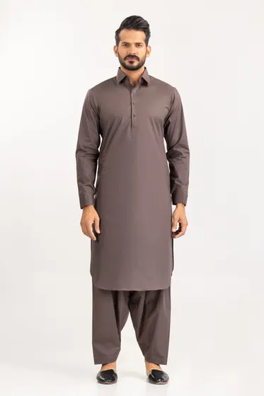[**PRODUCT DETAILS**](https://www.gulahmedshop.com/hitex-cool-unstitched-fabric-cotton-lf#description)

Craft your wardrobe of essentials with the finest fabrics of GulAhmed Men’s Collection.

* Premium Fine Quality 100% Cotton Fabric
* 4.5 MTR Suit Width 56 in

|  |  |
| --- | --- |
| More Information | |
| **NEW ARRIVALS:** | No |
| **GENDER:** | Men |
| **DISCOUNT PERCENTAGE:** | 31% to 40% |
| **SHIRT FABRIC:** | Cotton |

Hitex Cool Unstitched Fabric Cotton-LF

SKU

MEN-FABRIC-258451 -P

IN STOCK

PKR 4,091